Software Requirements Analysis
for
UWAM FRACAS System
Version 1.0 PENDING APPROVAL
Team CITS3200_43
16/08/2023
Table of Contents
Table of Contents ii
Revision History ii
Team Members ii
1. Introduction 1
1.1 Context 1
1.2 Team Members 1
1.3 Problem 1
1.4 Goal 1
2. Proposoed System 2
2.1 Overview 2
2.2 Alternative Considerations 2
2.3 Why? 2
2.4 Constraints 2
2.5 Client Considerations 3
3. Functional Requirements 3
3.1 User/Role Facing Stories 3
3.2 Feature Stories 4
3.2 Internal Functionality 5
4. Nonfunctional Requirements 5
4.1 User Interfaces & Human Factor 5
4.2 Documentation 5
4.3 Hardware Consideration 5
4.4 Performance Characteristics 5
4.5 Error Handling & Extreme Conditions 6
4.6 Quality Considerations 6
4.7 Security Considerations 6
4.8 Data Policy 6
4.9 Licensing Rights 6
5. System Model 7
5.1 Scenarios 7
5.2 Object Models 8
5.3 User Interface 8

Revision History
Name | Date | Reason For Changes | Version

Team Members
Insan Basrewan, Haoyuan Wang, Peter Tanner, Igor Pavkov, Harshawardhan Mane, Nicolas Baxter

Introduction

Context
This project was initially proposed by The University of Western Australia Motorsport club (UWAM), to develop a Failure, Reporting, Analysis and Corrective Action System (FRACAS). This will serve to address the current inefficiencies of knowledge transfer from experienced to new members and retain gained knowledge from members, after they’ve departed the club. Team CITS3200_43 is a group of students taking the CITS3200 unit, assigned to undertake this project, as part of the unit requirements.

Problem
UWAM lacks a system to collect & retain gained knowledge, as team composition changes on a regular basis
- Typically, new members enter as second year students and experienced members depart upon graduation.
- Member’s contribution varies as they are volunteers and have other primary commitments.
It takes significant resources to intake new members to become independent. Resources that could be spent for main competition efforts.
- Human Expense: Experienced members need to dedicate more time to training new members.
- Time Expense: Time could be accidentally spent on rediscovering established ideas and process and seeking out previous members for insight.

Goal
Design & develop a bespoke implementation of a FRACAS for UWAM, to meet the following goals.
- A streamlined process to create failure reports.
- A centralized hub to store and access all current and resolved failure reports.
- Failure reports to be validated, collected and kept in a structured format, for record keeping and future analysis.
- An easy-to-use platform to collaborate on current failures and learn from past failures.

Proposed System

Overview
We propose a fully functional FRACAS web application, with an integrated (SQL) database. An all-in-one website to draft structured failure reports with ease, view a library of previously recorded failure reports and extensive management tools to collaborate, review and learn from previous failures.

Alternative Considerations
We have considered alternative options such as a desktop/mobile application, Excel worksheet and other established software solutions to modify for this system (e.g. Trello, OpenBB, etc.). These options were ruled out for various reasons such as cost, limited modification/scalability options, limited team knowledge for a certain implementation and various factors that didn’t score as highly to meet the goals of this project, as our web app proposal.

Why?
We believe this an all-in-one web platform is the best approach for this system. Members will have a single point of access for failure report management, including creating, retrieving, reviewing failure reports, with controlled features desired for different levels of management. Not only that, but members will also have access to the system, from any modern device with a browser and internet connection, so members can file failure reports on the field or learn from previous failures at home.

This system can also meet long term record keeping requirements of failure reports, using a relational database management system (RDBMS), storing and manipulation of failure reports can be scalable towards the team’s growth, whilst ensuring reliable access, accurate record keeping and scalability. This is especially important, so anyone that’s looking to conduct deep data analytics, can interact with the database language (SQL) and retrieve records easily for their own research.

This implementation was also strongly favored by our team, as all of us have the most experience in designing web applications.

Constraints
In researching these requirements, we consider the following factors to constrain this project:
- Cost: As UWAM operates as a volunteer student run club, a low cost to maintain the system is preferred.
- Time: As the team designing and implementing this system is doing this as part of CITS3200 unit, our time to design and implement this system is limited to 10 weeks (including requirements gathering).

Client Considerations
Per client’s request, we have created our requirements, in consideration of client’s wish that the system be viable for use for 200+ concurrent users, hold at least 10 years’ worth of records and be secured to restrict access only to UWAM members.

In addition, the client has expressed interest that the system should be scalable in terms of extending the system’s functionality and allow access for future deep data analysis.

Functional Requirements
Priority
Priorities (inc. MVP) subject to revision, MVP items are targeted for Sprint 2 deliverables.
MVP – Minimum Viable Product, H – High, L – Low

User/Role Facing Stories
GM – General Member (Any user registered in the system)

Code | Description | Relevant Page | Priority | Status
GM1 | All members shall go through a login process, with their given credentials (email, password) | Login | MVP
GM2 | A process shall be created to invite new members to the system with their own credentials | Login, Admin | MVP
GM3 | Users can change passwords (even if forgotten) | Login, Admin | MVP

TL – Team Leader (Additional Functions for “Team Leader” Role)

Code | Description | Page | Priority | Status
TL1 | TL shall have validation and review privileges, restricted to their own team’s records | Record View | MVP
TL2 | TL can declare a report with 3 validation criteria (record, analysis, correction), with comments | Admin
TL3 | TL can declare a report’s review status, with comments | Admin
TL4 | TL can assign record ownership upon submission by a member (creator) and reassign if needed. | Record View | MVP
TL5 | TL can set and modify due dates of records | Record View | MVP
TL6 | TL can create learning assignments (assign a report to a member, with a due date) | Dashboard

AD – Admin (Additional Functions for “Admin” Role)

Code | Description | Page | Priority | Status
AD1 | Admin can assign admin and/or team leader roles to members | Admin | MVP
AD2 | Admin can create/remove teams | Admin | MVP
AD3 | Admin can create/remove members | Admin | MVP

Feature Stories
DASH – Dashboard (Separate Page. Items are listed as components within dashboard)

Code | Description | Role | Priority | Status
DASH1 | Personal Statistics | GM | MVP
DASH2 | Team Statistics | TL
DASH3 | Admin Statistics | AD
DASH4 | Draft Reports | GM
DASH5 | Pending Reports (Ownership, Validation, Review) | TL | MVP
DASH6 | Tasked Reports (owned reports, learning assignments) | GM
DASH7 | Relevant Reports (Owned, created, bookmarked), switchable views | GM | MVP

LIST – Record List (Separate Page. Items listed as functionality within page)

Code | Description | Role | Priority | Status
LIST1 | An ordered list of all available reports | GM | MVP
LIST2 | Search by keyword | GM
LIST3 | Filtered Searching (time, car year, team -> subsystem, owner) | GM
LIST4 | Item extra options (Bookmark, Duplicate) | GM | MVP
LIST5 | Sort By (alphabetical, date created, ascending/descending) | GM

VIEW – Record View (Separate page. Items listed as functionality within page)

Code | Description | Role | Priority | Status
VIEW1 | Presentable view of record | GM | MVP
VIEW2 | Comment section | GM
VIEW3 | Report edits/validation/review changes will be logged in comment section by system | GM
VIEW4 | Edit Screen for Admin & Owner | GM/AD | MVP
VIEW5 | Ability to export/print report | GM | L
VIEW6 | Validation/Review Screen | TL

REC – Record Creation (Separate page. Items listed as functionality within page)

Code | Description | Role | Priority | Status
REC1 | Record Creation page shall be accessible from anywhere on the website | GM | MVP
REC2 | Fields shall be set according to client provided example record | GM | MVP
REC3 | Certain fields will be auto filled by system (creation date, team context) | GM | MVP
REC4 | Each team will have a separate subsystem list, with a drop-down menu to either add a subsystem entry or use previously submitted subsystem during record creation | GM
REC5 | Buttons to save & close (draft), discard and publish shall be available in the screen | GM | MVP

Internal Functionality
SYS – Internal Systems Functionality

Code | Description | Role | Priority | Status
SYS1 | Notification system (due dates, pending ownership reports etc.) | GM
SYS2 | Error handler w/ pop up error messages for user | GM
SYS3 | Mobile browser capability | GM
SYS4 | Help page (user guide) | GM

Nonfunctional Requirements

User Interfaces & Human Factor
Members would interface with the system via a web browser on any modern device. The website would need to be designed to consider a novice, non-computer savvy user. This would include clear and intuitive navigation and access to core functionalities, and consistent design practices across the site, so users can become familiarized. In addition, users should be clearly informed and protected from making any anticipated errors, via error messages.

Documentation
Documentation shall be produced to provide UWAM members with sufficient reference on how to use the system and its functionalities. GitHub Wiki is recommended to allow future collaborators to extend the guide. Main priority is to outline the basic workflow of core tasks, for every user role.

An alternative to this would be a “help” button, that would be visible on any visible feature of the site, that would describe the functionality of a given component.

Hardware Consideration
The system will have to be hosted on an always on computer, with a static IP assigned (a server). We recommend Binary Lane, as a Virtual Private Server (VPS) provider for this system. Estimating exact performance requirements for the next 10 years, will require further investigating. But we believe their $7.50 per month VPS tier, will be able to handle 200+ members and approximately 100 new reports per week for at least 5 years, without degraded performance.

Performance Characteristics
As the system being proposed will be handling text-based data (no image or file upload), performance requirements would be relatively minimal. But any future to allow multimedia upload, could exponentially increase storage requirements. In the case of adding further live, complex data analysis, would require investigating of CPU and memory requirements (particularly once a decent library of failure reports has been established).

With VPS technology, it is possible to vertically scale computing needs (adding more CPU power, storage, ram) to meet greater demand, with little to no software reconfiguration and a short downtime (less than 5 minutes). This comes at a higher monthly cost, depending on future requirements.

Error Handling and Extreme Conditions
This project will have to assume that maintenance will be left to UWAM members, with limited software knowledge/experience. And that the software should be able to perform basic workflows without any hiccups. Quality assurance (QA) testing will have to be conducted, per requirement. This will ensure the system will be able to catch or mitigate any potential errors that might prop up in normal use. An error handler would be needed to catch any unforeseen errors, as to not unnecessarily halt the system.

In the extreme event the system becomes responsive, or basic functionality is interrupted. A troubleshooting guide will need to be produced as to instruct admins on how to restart the system.

Quality Considerations
We can assume that the system should be highly available and limit downtimes to scheduled maintenance. The system should also be a responsive experience to use (loading animations when anticipated should be implemented).

Security Considerations
As the system will be exposed to the internet, precautions will have to be taken to ensure system and data integrity. An emphasis on the login and signup system to ensure its robustness, shall be considered. As this should be the only page accessible to any non-members. Admins and members would also be expected to maintain basic internet security practices, just as they would with any other online accounts they have.

To ensure record integrity, a backup regiment of the database will be needed, in the event of any software or external catastrophic failure. Binary Lane has a built-in backup and restore solution, to schedule automatic backups, at a cost of 10c per gigabyte of backup storage.

Data Policy
Collection of data should be limited to only the necessary details, for the scope of this project. The system will retain email addresses and names of members, even after their departure, for failure reports. This should be addressed when a new member joins UWAM and to current UWAM members. No other personal detail of members should be collected.

Licensing Rights
We believe the software should be open source. We recommend GNU GPLv3. This will allow the software to be used and forked by others, but it does encourage collaboration to the original source code to extend features, maintain and report issues.

System Model

Scenarios
Creating a new report
A suspension component has failed during a practice session. Whilst the suspensions team scrambles to investigate the car, one member (Devon) is tasked to draft the failure report. Devon opens his laptop, connected to the hotspot of his phone, logs in to the website of the system and clicks the “create new report” button.
Devon gets news that specifically the tie rods have failed. The subsystem list doesn’t have “tie rods” listed, as it seems to be a component that hasn’t failed in the past. So, he selects the option to add “tie rods” as a new subsystem, so future failure reports can select “tie rods” in the drop-down menu of the subsystem. Devon then clicks “current time” in the time of failure field, the 2023-year option in the car year field and then writes a brief description of the failure.

As impact and cause is not known yet at this time, he then submits the report, which will the go to the notification inbox of the suspension team leader, to assign an owner of that report later.

Report: From Ownership to Resolved
The suspension team leader (Emma), receives a new notification of a report from within her team, pending an owner. Emma then assigns ownership to an experienced member (Alan), adds a due date for a validation check.

Due date comes, Emma sees the report description has been updated, along with the impact, cause, mechanism and corrective action plan information added by Alan. Emma is satisfied with the information and marks the record, analysis and correction status as validated and updates the due date for a review.

Second due date comes, Emma reviews the report and sees a comment by Alan and other members regarding the success of the corrective action plan. Emma is satisfied with this report and selects the current time in the “time resolved” field, to mark the report as resolved.

Viewing Previous Reports
Jemma is a new member of the suspension team and is still catching up to speed with everyone else. She’s been tasked to design the tie rods for next year’s car. Jemma’s team leader refers her to look at previous failure reports to avoid making the same mistakes with previous year’s design. Jemma logs in to the website and clicks “Library” in the navigation bar, to look at all the previously submitted failure reports. Jemma then does a filtered search of her team and subsystem “tie rods”. The site returns a list of failure reports with “tie rods” as the subsystem. She opens the most recent one and bookmarks that report for future reading.

Sign Up
Thomas is studying engineering and is looking to join UWAM’s powertrain team. After the formal induction process, the powertrain team leader gives Thomas a special sign-up link that allows access to the sign-up page and automatic allocation to the powertrain team. Thomas can then register his name, email and password. After which, he will then be able to log in and automatically be part of powertrain team in the system.

Object Models
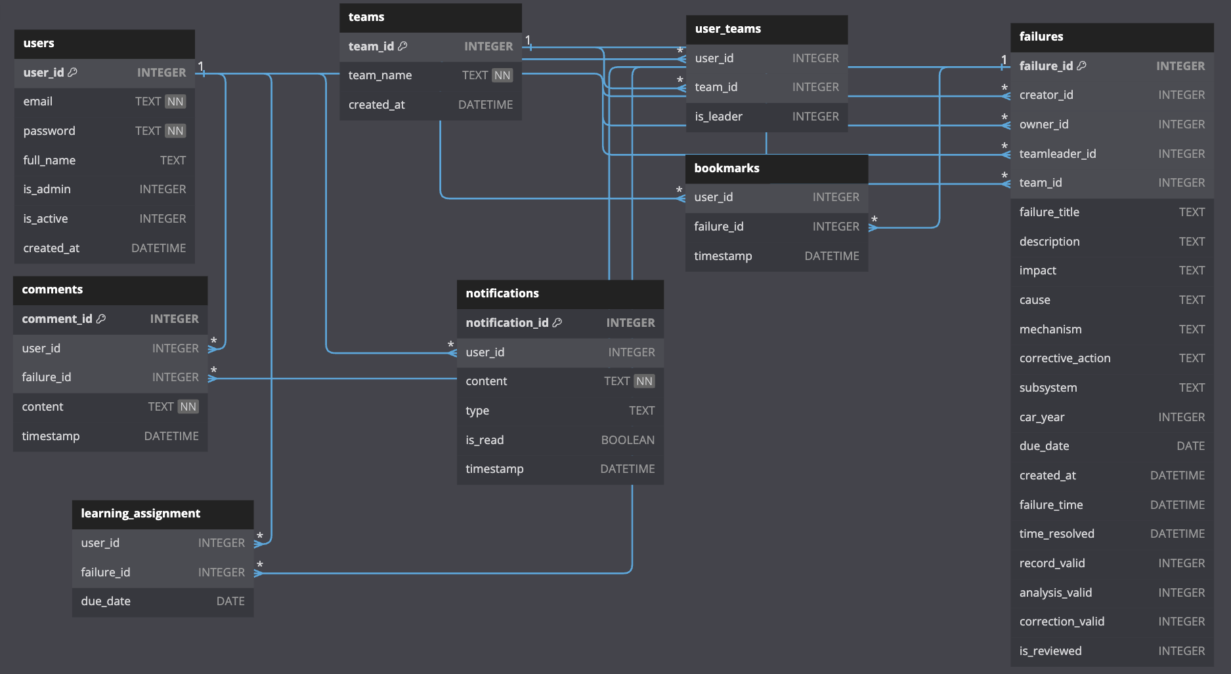
Refer to the database diagram below (subject to revision). The failure table includes a list of fields, as specified by the client.

User Interface (Navigation Paths & Mockups)
Refer to the “Mockups” folder, delivered along with this document, as part of Sprint 1 deliverables. The mockups are to only illustrate a sample of showcased pages. Design elements still subject to revision and does not resemble the final product.

